[Project Name]

Integrated Project Plan

Author: [Name]
Date: [Date]
Issue Number: 1

Revision History

Version | Date | Author | Revision Description

Approval

Name | Title | Department | Date / Signature

Terminology

Define any unique or significant terms and/or acronyms that will be commonly used within the project. Terms that may be new or confusing to project stakeholders should be clearly explained

Terminology | Description

Contents

Background

Problem/Opportunity
Describe briefly the problem/opportunity to be solved - from the product description.

Context or Alignment
Describe briefly any relationship with other internal or external projects.

Scope Statement
The project scope includes all the work required, and only the work required to successfully complete the project. The defined work will be an integration of the work required to plan and manage the project with the work to define, implement and support the customers request. The following indicates what is in scope for this project:

Objectives & Measurements
Objectives provide the foundation for defining scope and include measurements that indicate clear achievement of the objective.
The following are measurable project objectives, which have been refined from the business need in the approved product description. Each objective may contain one or more measurements that will indicate clear progress towards or achievement of the objective.
The project will manage scope development and change to ensure the project objectives remain the basis for defining the high-level to specific requirements needed to deliver the product or service.

Major Deliverable Milestones

MS# | Milestone Description | Planned  Complete
MS1 <Milestone Title>  <Describe briefly in business terms what will have occurred by this milestone>. |  | <Date>
MS2 <Milestone Title>  <Describe briefly in business terms what will have occurred by this milestone>. |  | <Date>
MS3 <Milestone Title>  <Describe briefly in business terms what will have occurred by this milestone>. |  | <Date>

Assumptions
Define any known planning assumptions.

Completion Criteria
Define what will indicate that the project has been completed and at what point the ongoing work can and should be turned over to standard operations and routine maintenance.

Work Plan

Schedule
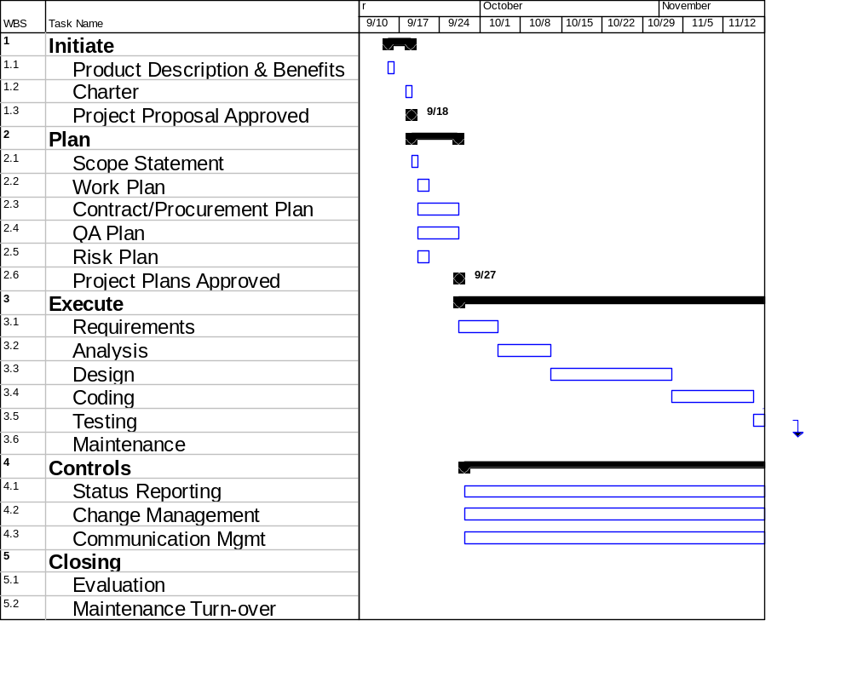
Paste a high-level Gantt chart of the schedule showing the major phase areas and timing bars. The following is an example to be replace with the real schedule.

Budget Estimate
Indicate an approximate monthly spending plan of resource time for both the business and technical staff in full time equivalents (FTE). Indicate an approximate monthly spending plan in other project costs. The following is an example:

Organization

Project Team Composition
Create a simple org chart of the project, i.e. from the sponsor, steering committee, project management team, internal business and technical staff, and other support roles needed to complete the project. Larger or riskier project may wish to do more detailed roles and responsibilities as the project progresses

Internal Roles & Responsibilities
Describe briefly the roles and responsibilities of each of the individuals or groups illustrated in the organization chart who are internal to the project.

Other Group Roles & Responsibilities
Describe briefly all other group roles and responsibilities that will need to perform work in support of the project. These other groups work assignments will be a part of the project schedule.

Facilitating Controls
Note to template user – the level of adaptation and application of facilitating controls should be adjusted based on the business and technical complexity assessment. Riskier projects should consider creating the more formal facilitating control plans and reference them below. The lower risk projects should describe very briefly how they would perform these activities by modifying the boilerplate language to reality (i.e. changes will be evaluated by the project manager and informally approved by the sponsor as they occur).

Change Management
All changes will be logged and evaluated for impact to the project and product scope, schedule, and cost. The lead consultant, sponsor, and project manager or other role will recommend whether to incorporate the changes or hold changes for a future release. All suggested changes to the process, activities, tasks or defined deliverables will go to the lead consultant or other role for analysis.
Note to template user – depending on the type, size, and risk of the project the change management plan may require more rigorous change management that specifically details how scope and requirement changes will be managed, and how schedule and cost changes will be managed and what process, tools and techniques will be used by the project. For more details see the Change Management Plan template.
A Change Management Plan will be developed using the Change Management Plan template located in the project controls section of the project file or notebook. This plan will be used to incorporate agreed upon changes into the project.

Quality Management
The purpose of the Quality Management Plan is to develop a reasonable and appropriate method for an objective review of how well the project is following the projects’ plans and controls to deliver the requested product and meet the standards of the agency and DAS oversight requirements. The review will include areas of insufficiency in the project’s plan and processes, as well as, insufficiency in the project’s ability to carry out the plan. It will also include recommendations for improvement for each QA finding.

Risk Management Plan
The project manager will identify project risks relating to schedule, costs, or quality. For each identified risk an agreed mitigation will be determined. Some mitigation is expected to be informal and handled by sponsor decision or action, other mitigation will be planned and responsibility assigned for carrying out the mitigation plan.
A Risk Management Plan will be developed using the Risk Management Plan template located in the project templates section of the project office folder on network. This plan will be used to manage the risks of the project.

Communications Management Plan
The purpose of the projects Communication Management Plan is to determine communication needs of all people within the organization and possibly external to the organization that will be affected by the project: who needs what information, when will they need it, and how it will be given to them. Communication Management includes communications of project performance measures, status reporting, and distribution and storage of information about the project.
A Communication Plan will be developed using the Communication Plan template located in the project templates section of the project office folder on network. This plan will be used to appropriately communicate the project to the affected parties of the project.

Status Reporting
The project manager will deliver status reporting to the steering committee and sponsor formally on a periodic basis during regularly scheduled meetings <state frequency>. Informal status will be given weekly at the regularly scheduled team meetings. The outline of the formal status reporting will be as follows:
- Status Summary – This section is a high-level view of the project and progress against the major activities. An indicator of percent complete for each key deliverable will be given.
- Problems Resolved Since Last Report – This section covers resolutions to delays, problems, actions, and implications since the last status.
- Accomplishments Since Last Report – This section lists the main critical deliverables since the last report.
- New Problems/Concerns - This section covers delays, problems, actions, and implications since the last status.
- Next Period Planned Activities – This section defines the immediate next steps.
A Status Report Template to be used by this project is located in the project controls section of the project file or notebook.

Summary
Summarize the sections below highlighting significant accomplishments; provide an overall assessment of project status and outlook (schedule, budget and, if a significant issue, staffing); and highlight any issues requiring management decisions and management support.

Accomplishments this Reporting Period, dd/mm/yyyy – dd/mm/yyyy
List important accomplishment for the period. Accomplishments should consist of project deliverables, milestones or significant tasks on the project plan that have been completed in that time period. Progress made on major tasks may also be discussed.

Analysis of Variances from the Baseline Plan and Corrective Actions
This section should explain the reasons for any schedule and/ or cost variances and the impact of these variances on the ability to meet the overall project target dates and budget. Also include corrective actions associated with each variance.

Issues
This section should identify important issues, their potential impact on the project and how and when they are going to be resolved or need to be resolved in order to meet the project goals.

Planned Activities for the Next Reporting Period, dd/mm/yyyy – dd/mm/yyyy

Attachments
May include the Schedule Chart and Budget Spreadsheet.

Issue & Decision Management
The plan for Issue Management is to provide a method to identify and resolve the issues that impact the scope, schedule, cost or quality of the project.
The plan includes (1) a method to identify and analyze issues impacting project progress and (2) a means to achieve and document the planned resolution and decisions.
Issues that the Project Manager cannot resolve will go to the steering committee and ultimately the sponsor for a final resolution or decision.
A Issue and Decision Management Plan will be developed using the Issue Management Plan template located in the project templates section of the project office folder on network. This plan will be used to appropriately identify and resolve and record issues and decisions made during the course of the project.

Project Document Standards, Approval, and Controls
Document Standards – the project will use a consistent document style and layout for internal and external products produced. The standard word process tool will be MS Word.
Changes to formal documents will be tracked via a change activity log located in the document.
All internal work products being drafted or revised will be located in a shared area.
A standard electronic project directory will organize the project documentation. A physical project library will organize the hard copy materials. Both the electronic and physical libraries will be structured similarly. They layout of the electronic libraries is located in the project templates section of the project office folder on network.

Cost Management Plan
Briefly describe how the project budget, cost and committed costs will be tracked and managed. Larger projects may required a separate Cost Management Plan to cover the process, tools and techniques the project will use to manage the various aspects of the budget and costs.

Procurements & Contracts
The purpose of the Contract Management Plan is to select qualified contractors to do specific pieces of work on the project plan and manage them effectively. The project management team performs the planning, tracking, and oversight activities to ensure the contractors work is performed appropriately and that the products delivered by the contractors satisfy the agreed upon acceptance criteria.
A Contract Management Plan will be developed using the Contract Management Plan template located in the project controls section of the project file or notebook. This plan will be used to manage and track the performance of the contracts used on this project.

Resource Tracking
The purpose of Resource Tracking is to monitor the actual resource expenditures (time and costs) against the plan to spot variances early and make appropriate decisions on how to correct the problems before they are out of hand. The plan will be reflected in the project schedule and the staff will report time expenditures per task to the project manager. Other project cost will be tracked through the regular accounting process. The project manager will record actuals against the plan in the scheduling tool and report variance as part of the regular status reporting.

